The Online Learning Experience: Exploring Student Course Consumption and Completion

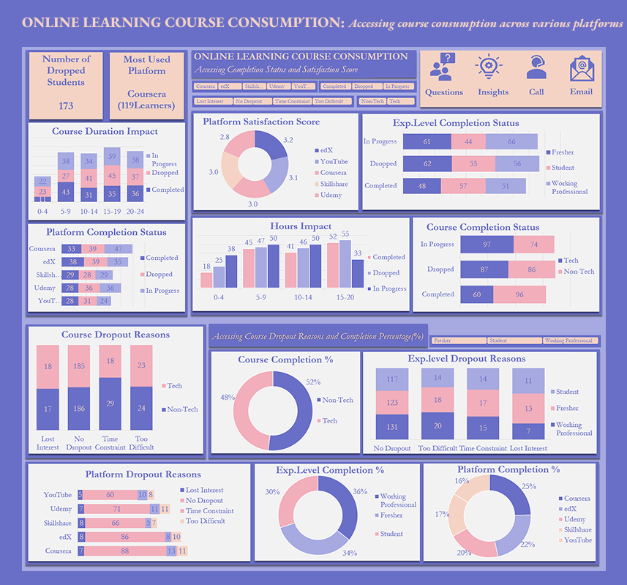
Online Learning Course Consumption for Students, 2024.

Introduction:
In the EdTech industry, understanding how learners interact with online courses is important for improving course completion, learner satisfaction, and platform growth. The Online Learning Course Consumption dataset provides a comprehensive view of the learning behaviour of Freshers, Students, and Working Professionals who consume both Technical and Non-Technical courses across different online learning platforms.
The dataset contains information such as experience level, course type, learning platform, hours spent per week, course duration, completion status, completion percentage, dropout reason, and satisfaction score. These variables provide an opportunity to understand the factors associated with learners' completion of online courses and their overall learning experience.
This analysis examines how factors such as course type, platform, experience level, hours spent per week, and course duration are associated with learning outcomes. It also explores the reasons learners drop out and how learner satisfaction differs across platforms.
The findings from this analysis can provide useful insights for EdTech platform providers, learners, and course creators. These stakeholders can use the findings to improve course structures, provide better learner support, reduce dropout rates, increase completion rates, and improve learner satisfaction.

Objectives:
- To identify course types with the highest and lowest completion rates.
- To understand why learners drop out of specific course types.
- To identify which course types have the highest completion percentages.
- To identify the hours per week associated with higher course completion.
- To compare completion rates across different online learning platforms.
- To identify platform-specific dropout patterns.
- To assess platform performance based on learner satisfaction.
- To compare platform effectiveness based on completion percentage.
- To understand why learners drop out based on their experience level.
- To examine completion rates across different experience levels.
- To determine how experience level is associated with completion percentage.
- To examine whether course duration is associated with course completion.

Methodology:
The next step taken for this analysis was to input the data into pivot tables in Microsoft Excel to examine the relationship between the independent and dependent variables. The resulting pivot tables were then used to create charts and dashboards that helped to identify patterns in course completion, dropout behaviour, and learner satisfaction.
The analysis focused on Experience Level, Course Type, Platform, Hours Spent Per Week, and Course Duration as the independent variables, while Completion Status, Completion Percentage, Dropout Reason, and Satisfaction Score were treated as the dependent variables.
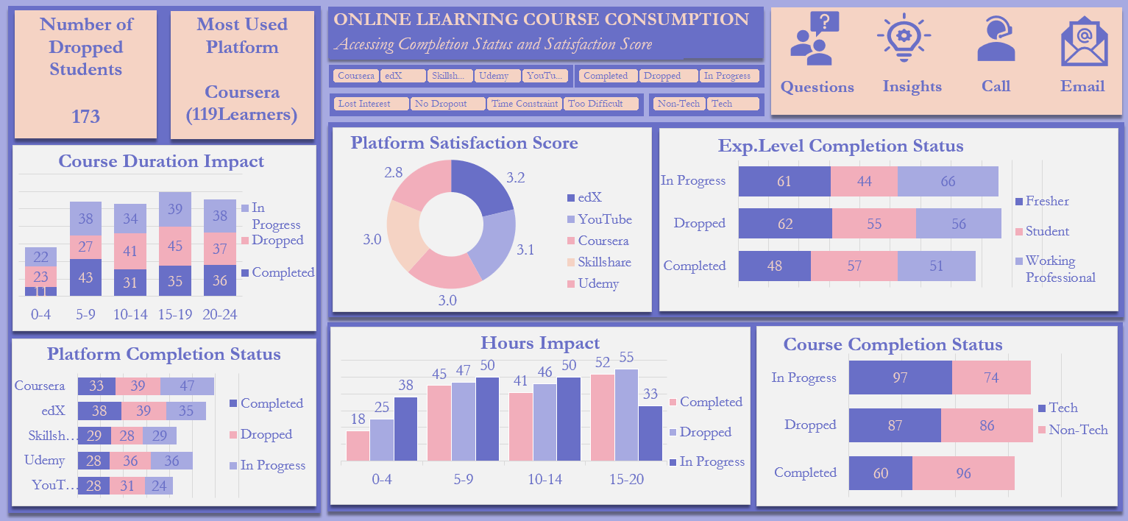
A. Course Duration vs Completion Status (Stacked Column Chart)
The chart shows the relationship between course duration and completion status.
- For courses lasting 0–4 weeks, 11 learners completed, 23 dropped out, and 22 were still in progress.
- For 5–9 weeks, 43 completed, 27 dropped, and 38 were in progress.
- For 10–14 weeks, 31 completed, 41 dropped, and 34 were in progress.
- For 15–19 weeks, 35 completed, 45 dropped, and 39 were in progress.
- For 20–24 weeks, 36 completed, 37 dropped, and 38 were in progress.
The 5–9 week category recorded the highest number of completions, while the 15–19 week category recorded the highest number of dropouts. This suggests that course duration may be associated with completion and dropout patterns, although the relationship is not simply that shorter courses always perform better.
B. Platform vs Satisfaction Score (Donut Chart)
The average satisfaction score across the platforms was:
- edX – 3.2
- YouTube – 3.1
- Coursera – 3.0
- Skillshare – 3.0
- Udemy – 2.8
edX had the highest average satisfaction score, while Udemy had the lowest. This suggests that learners' experiences differ across platforms and that there may be opportunities for platforms with lower satisfaction scores to improve their learner experience.

C. Experience Level vs Completion Status (Stacked Bar Chart)
The chart shows the relationship between learners' experience level and their completion status.
- Freshers recorded 48 completions, 62 dropouts, and 61 learners in progress.
- Students recorded 57 completions, 55 dropouts, and 44 learners in progress.
- Working Professionals recorded 51 completions, 56 dropouts, and 66 learners in progress.
Students had the highest number of completed learners, while Working Professionals had the highest number of learners still in progress.
D. Platform vs Completion Status (Stacked Bar Chart)
The chart shows how completion status differs across Coursera, edX, Skillshare, Udemy, and YouTube.
- Coursera recorded 33 completed, 39 dropped, and 47 in progress.
- edX recorded 38 completed, 39 dropped, and 35 in progress.
- Skillshare recorded 29 completed, 28 dropped, and 29 in progress.
- Udemy recorded 28 completed, 36 dropped, and 36 in progress.
- YouTube recorded 28 completed, 31 dropped, and 24 in progress.
edX recorded the highest number of completed learners among the platforms, while Coursera had the highest number of learners still in progress.
E. Hours Spent Per Week vs Completion Status (Clustered Column Chart)
The chart shows the relationship between the number of hours learners spend on their courses each week and their completion status.
- Learners who spent 0–4 hours per week recorded 18 completions, 25 dropouts, and 38 learners still in progress.
- Those who spent 5–9 hours recorded 45 completions, 47 dropouts, and 50 learners in progress.
- Learners who spent 10–14 hours recorded 41 completions, 46 dropouts, and 50 learners in progress.
- Those who spent 15–20 hours recorded the highest number of completions at 52, but also had the highest number of dropouts at 55.
This indicates that spending more time on courses is associated with more completions, but it may also be associated with more dropouts. Higher engagement can therefore have both positive and negative outcomes depending on the learner's experience and ability to manage the course workload.
F. Course Type vs Completion Status (Stacked Bar Chart)
The chart shows the relationship between course type and completion status. For Non-Tech courses, out of 256 learners, 96 completed their courses, 86 dropped out, and 74 were still in progress.
For Tech courses, out of 244 learners, 60 completed their courses, 87 dropped out, and 97 were still in progress.
This shows that Non-Tech courses recorded more completed learners than Tech courses. However, Tech courses had more learners who were still in progress. This may suggest that the lower number of completed Tech learners does not necessarily mean that all those learners will eventually drop out, as many were still actively learning.
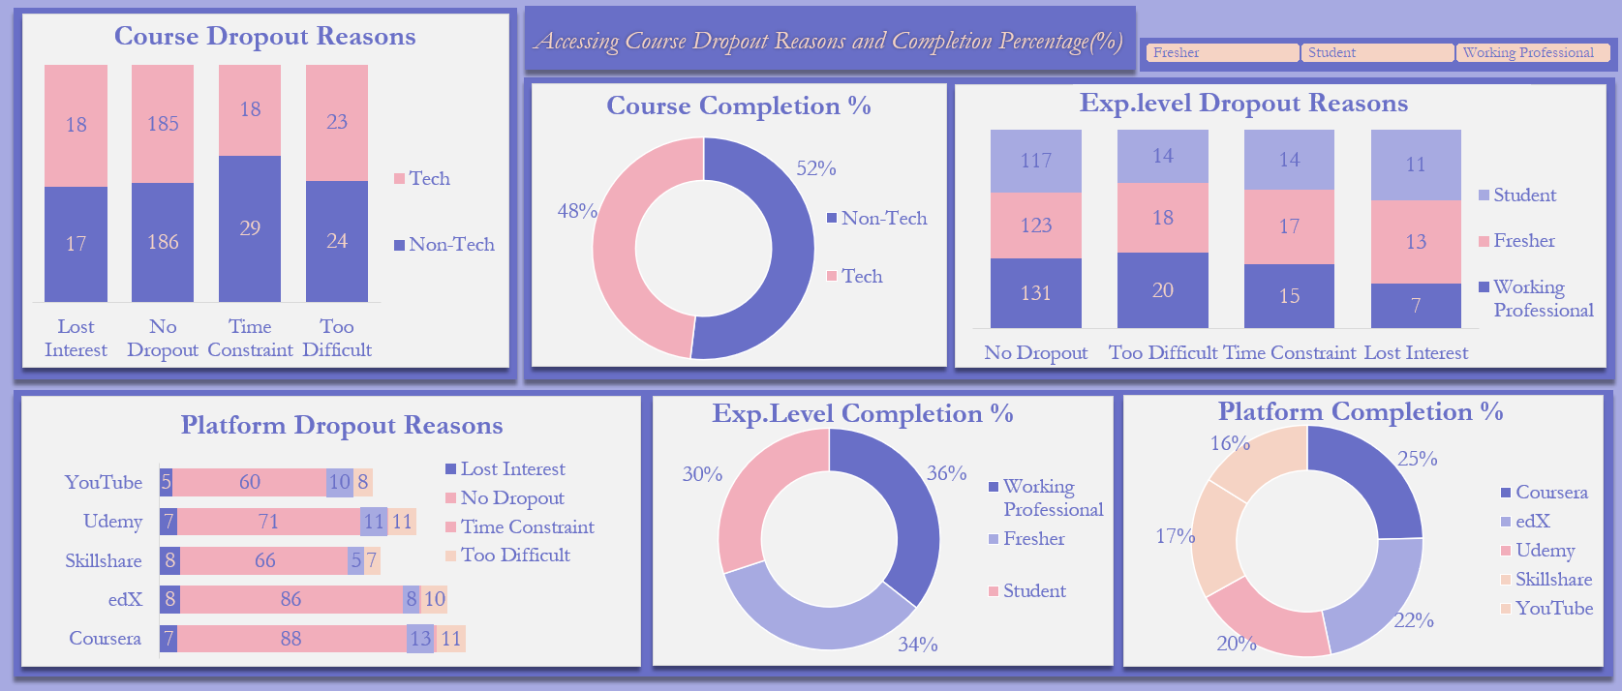
A. Course Dropout Reasons (Stacked Column Chart)
The chart examines the reasons learners dropped out of Technical and Non-Technical courses.
- For Tech courses, 18 learners lost interest, 18 experienced time constraints, and 23 found the courses too difficult, while 185 learners had no dropout.
- For Non-Tech courses, 17 learners lost interest, 29 experienced time constraints, and 24 found the courses too difficult, while 186 learners had no dropout.
Course difficulty and time constraints appear to be important dropout-related issues across both course types. Time constraint was particularly noticeable among Non-Tech learners, while course difficulty was slightly higher among Tech learners.
B. Course Completion Percentage (Donut Chart)
The chart shows the percentage distribution of completed learners between Technical and Non-Technical courses.
Non-Tech courses accounted for 52% of completed learning, while Tech courses accounted for 48%.
This indicates that Non-Tech courses had a slightly higher completion share than Tech courses.
C. Experience Level vs Dropout Reasons (Stacked Column Chart)
The analysis shows that dropout reasons vary across experience levels.
- Among Working Professionals, 7 learners lost interest, 15 experienced time constraints, and 20 found the course too difficult.
- Among Freshers, 17 lost interest, 18 experienced time constraints, and 13 found the course too difficult.
- Among Students, 11 lost interest, 14 experienced time constraints, and 14 found the course too difficult.
- Course difficulty was the most prominent reported reason among Working Professionals, while Freshers recorded the highest number of learners who lost interest.
D. Platform Dropout Reasons (Stacked Bar Chart)
The chart examines the different dropout reasons across online learning platforms.
- For Coursera, 7 learners lost interest, 13 dropped out because of time constraints, and 11 found the course too difficult, while 88 had no dropout.
- For edX, 8 learners lost interest, 8 experienced time constraints, and 10 found the course too difficult, while 86 had no dropout.
- For Udemy, 7 learners lost interest, 11 experienced time constraints, and 11 found the course too difficult, while 71 had no dropout.
- For Skillshare, 8 learners lost interest, 5 experienced time constraints, and 7 found the course too difficult, while 66 had no dropout.
- For YouTube, 5 learners lost interest, 10 experienced time constraints, and 8 found the course too difficult, while 60 had no dropout.
Time constraints and course difficulty appear repeatedly across the platforms as important reasons associated with learner dropout.
E. Experience Level vs Completion Percentage (Donut Chart)
The completion percentage by experience level was:
- Working Professionals – 36%
- Freshers – 34%
- Students – 30%
Working Professionals recorded the highest completion percentage, while Students recorded the lowest.
F. Platform Completion (Donut Chart)
The platform completion analysis shows that:
- Coursera accounted for 25% of completed learners.
- edX accounted for 22%.
- Udemy accounted for 20%.
- Skillshare accounted for 17%.
- YouTube accounted for 16%.
Coursera had the highest share of completed learners, while YouTube had the lowest.

Story of Data:
This project is an EdTech project that examines online learning behaviour among Freshers, Students, and Working Professionals.
The dataset shows how learners consume Technical and Non-Technical courses across different online learning platforms, including YouTube, Coursera, Udemy, Skillshare, and edX.
It provides information about the learners' experience level, course type, platform, hours spent per week, course duration, completion status, completion percentage, dropout reason, and satisfaction score.
The data provides an opportunity to understand the behaviours and circumstances associated with learners completing courses, remaining in progress, or dropping out. It also provides information that can help identify opportunities for improving learner satisfaction and platform performance.
The dataset is a public dataset obtained from Kaggle.

Data Splitting and Preprocessing:

- Data Cleaning
The dataset was obtained from Kaggle and loaded into a Microsoft Excel workbook for analysis. The data was organized and reviewed to ensure that the variables could be properly analyzed using pivot tables and charts.
The analysis was carried out in Microsoft Excel, where the data was summarized using pivot tables and subsequently represented through different visualizations and dashboards.

- Data Splitting

Independent Variables
- Experience Level
- Course Type
- Platform
- Hours Spent Per Week
- Course Duration (Weeks)

Dependent Variables
- Completion Status
- Completion Percentage
- Dropout Reason
- Satisfaction Score

Industry Context and Stakeholders
This project is connected with the EdTech Industry, with a focus on understanding online learning behaviour and the factors associated with course completion, dropout, and learner satisfaction.
The major stakeholders affected by the findings include:
- EdTech Platform Providers – such as Coursera, edX, Udemy, Skillshare, and YouTube.
- Learners/Students – who use online platforms to acquire knowledge and skills.
- Authors/Course Creators – who design and deliver online learning content.

Potential-Analysis Questions:
- Are certain course types more likely to be completed?
- Why do learners drop out of specific course types?
- Which course types have the highest completion percentages?
- Do learners who spend more hours per week complete courses more often?
- Do completion rates vary across different platforms?
- What are the common dropout reasons on each platform?
- How do platforms compare based on learner satisfaction?
- Which platforms have the highest completion percentages?
- Do dropout reasons differ by experience level?
- Are Working Professionals more likely to complete courses than Students?
- Do more experienced learners complete more courses?
- Are shorter or longer courses more likely to be completed?

Pre-Analysis Insights:
- To identify the course types associated with higher completion rates and determine possible reasons for differences between Technical and Non-Technical courses.
- To understand the reasons learners drop out of different course types and identify areas where course providers can offer additional support.
- To identify the course types with higher completion percentages.
- To understand the amount of time learners spend studying each week and determine whether greater time investment is associated with completion.
- To compare the completion performance of different online learning platforms.
- To identify platform-specific dropout patterns and understand the major challenges learners experience.
- To compare learner satisfaction across platforms and identify platforms that may require improvements.
- To identify which platforms have higher completion shares.
- To understand the reasons for dropout among Freshers, Students, and Working Professionals.
- To examine completion patterns across different experience levels.
- To determine whether experience level is associated with completion.
- To investigate whether course duration is associated with completion and dropout patterns.

Data Visualizations:
- Course Type vs Completion Status: A Stacked Bar/Column Chart was used.
- Hours Spent Per Week vs Completion Status: A Column Chart was used.
- Platform vs Completion Status: A Bar Chart was used.
- Experience Level vs Completion Status: A Stacked Bar Chart was used.
- Course Dropout Reasons: A Stacked Column Chart was used.
- Course Completion Percentage: A Doughnut/Pie Chart was used.
- Platform Dropout Reasons: A Stacked Bar Chart was used.
- Platform Completion Percentage: A Doughnut/Pie Chart was used.
- Course Duration vs Completion Status: A Stacked Column Chart was used.
- Experience Level vs Dropout Reasons: A Stacked Column Chart was used.
- Platform Satisfaction Score: A Doughnut Chart was used.
- Experience Level vs Completion Percentage: A Doughnut Chart was used.

In-Analysis Observations:

Analysis: Course Type vs Completion Status
- For Non-Tech courses, 96 learners completed their courses, 86 dropped out, and 74 were still in progress.
- For Tech courses, 60 learners completed their courses, 87 dropped out, and 97 were still in progress.
- Non-Tech courses recorded more completed learners than Tech courses.
- Tech courses recorded more learners who were still in progress.

Recommendations
- The reasons behind the lower number of completed Tech learners should be investigated.
- Course structures should be compared to determine whether Tech courses are more difficult or demanding.
- Support should be provided to learners who are still in progress to encourage them to complete their courses.
- Dropout reasons should be examined so that common challenges can be addressed.

Analysis: Hours Spent vs Completion Status
- Learners who spent 0–4 hours per week recorded 18 completions, 25 dropouts, and 38 learners in progress.
- Learners who spent 5–9 hours recorded 45 completions, 47 dropouts, and 50 learners in progress.
- Learners who spent 10–14 hours recorded 41 completions, 46 dropouts, and 50 learners in progress.
- Learners who spent 15–20 hours recorded the highest number of completions at 52, but also the highest number of dropouts at 55.
- More hours are associated with more completions, but also with more dropouts.
Recommendations
- Learners spending fewer hours should be encouraged and supported to maintain steady progress.
- Course providers should investigate why learners spending 15–20 hours have relatively high dropout numbers despite also recording high completion numbers.
- Courses should provide flexible learning schedules that accommodate different learner commitments.
- Learners should be encouraged to balance study time with rest and other responsibilities.

Analysis: Platform vs Completion Status
- Coursera recorded 33 completed learners, 39 dropouts, and 47 learners in progress.
- edX recorded 38 completed learners, 39 dropouts, and 35 learners in progress.
- Skillshare recorded 29 completed learners, 28 dropouts, and 29 learners in progress.
- Udemy recorded 28 completed learners, 36 dropouts, and 36 learners in progress.
- YouTube recorded 28 completed learners, 31 dropouts, and 24 learners in progress.
- edX recorded the highest number of completed learners among the platforms.

Recommendations
- Learners who are still in progress should be encouraged to continue and complete their courses.
- Platforms should investigate their dropout reasons to determine whether courses are too difficult or poorly suited to learners.
- Platforms can compare course structures and learner support systems to identify practices associated with stronger completion outcomes.

Analysis: Experience Level vs Completion Status
- Freshers recorded 48 completed learners, 62 dropouts, and 61 learners in progress.
- Students recorded 57 completed learners, 55 dropouts, and 44 learners in progress.
- Working Professionals recorded 51 completed learners, 56 dropouts, and 66 learners in progress.
- Students recorded the highest number of completed learners.
- Working Professionals had the highest number of learners still in progress.

Recommendations
- Course fit and difficulty should be reviewed for the different learner groups.
- Learners who are still in progress should receive reminders and support to encourage course completion.
- Platforms should consider developing different support strategies for Freshers, Students, and Working Professionals.

Analysis: Course Dropout Reasons
- Among Tech learners, 18 lost interest, 18 experienced time constraints, and 23 found the course too difficult.
- Among Non-Tech learners, 17 lost interest, 29 experienced time constraints, and 24 found the course too difficult.
- Course difficulty and time constraints are important dropout-related issues across both course types.
- Time constraint was more prominent among Non-Tech learners.

Recommendations
- Course difficulty should be reviewed and simplified where necessary.
- Courses should be designed in manageable sections to make learning easier.
- Flexible schedules should be considered for learners who struggle with time constraints.
- Additional learning resources should be provided to learners who experience difficulty with course content.

Analysis: Course Completion Percentage
- Non-Tech courses accounted for 52% of completed learning.
- Tech courses accounted for 48%.
- Non-Tech courses therefore recorded a slightly higher completion share.

Recommendations
- The strengths of Non-Tech course structures should be identified and used as a benchmark.
- Tech courses should be reviewed to identify factors that may be associated with lower completion.
- Learners taking Tech courses should receive appropriate academic and technical support.

Analysis: Platform Dropout Reasons
- Coursera recorded 7 learners who lost interest, 13 who experienced time constraints, and 11 who found courses too difficult.
- edX recorded 8 learners who lost interest, 8 who experienced time constraints, and 10 who found courses too difficult.
- Udemy recorded 7 learners who lost interest, 11 who experienced time constraints, and 11 who found courses too difficult.
- Skillshare recorded 8 learners who lost interest, 5 who experienced time constraints, and 7 who found courses too difficult.
- YouTube recorded 5 learners who lost interest, 10 who experienced time constraints, and 8 who found courses too difficult.
- Time constraints and course difficulty appear across multiple platforms as important dropout-related issues.

Recommendations
- Platforms should investigate the major causes of dropout among their learners.
- Time constraints should be addressed through flexible learning structures.
- Course difficulty should be reviewed and appropriate learning support should be provided.
- Platforms should monitor dropout reasons regularly to identify emerging problems.

Analysis: Platform Completion
- Coursera had the highest completion share at 25%.
- edX recorded 22%.
- Udemy recorded 20%.
- Skillshare recorded 17%.
- YouTube recorded the lowest completion share at 16%.

Recommendations
- YouTube should investigate the factors associated with its lower completion share.
- Platforms with higher completion performance should identify practices that could be adopted across the industry.
- Platforms should focus on improving learner engagement and support throughout the learning process.

Analysis: Course Duration vs Completion Status
- Courses lasting 0–4 weeks recorded 11 completions, 23 dropouts, and 22 learners in progress.
- Courses lasting 5–9 weeks recorded 43 completions, 27 dropouts, and 38 learners in progress.
- Courses lasting 10–14 weeks recorded 31 completions, 41 dropouts, and 34 learners in progress.
- Courses lasting 15–19 weeks recorded 35 completions, 45 dropouts, and 39 learners in progress.
- Courses lasting 20–24 weeks recorded 36 completions, 37 dropouts, and 38 learners in progress.
- The 5–9 week category recorded the highest number of completions.
- The 15–19 week category recorded the highest number of dropouts.

Recommendations
- Reasons for the high dropout count among very short courses should be investigated.
- Longer courses should be reviewed to determine whether course content is too extensive.
- Long courses could be divided into smaller modules to make them easier to complete.
- Course duration should be designed around realistic learner commitments.

Analysis: Experience Level vs Dropout Reasons
- Working Professionals recorded 7 learners who lost interest, 15 who experienced time constraints, and 20 who found courses too difficult.
- Freshers recorded 17 who lost interest, 18 who experienced time constraints, and 13 who found courses too difficult.
- Students recorded 11 who lost interest, 14 who experienced time constraints, and 14 who found courses too difficult.
- Course difficulty was the highest reported dropout reason among Working Professionals.
- Freshers had the highest number of learners who lost interest.

Recommendations
- More engaging content should be developed for Freshers.
- Course difficulty should be reduced or better supported for Working Professionals.
- Flexible learning schedules should be provided for learners with time constraints.
- Different learner groups should receive support based on their specific challenges.

Analysis: Platform Satisfaction Score
The average satisfaction scores were:
- edX – 3.2
- YouTube – 3.1
- Coursera – 3.0
- Skillshare – 3.0
- Udemy – 2.8
edX had the highest average satisfaction score, while Udemy had the lowest.

Recommendations
- Udemy should investigate the reasons behind its lower satisfaction score.
- Platforms should collect regular feedback from learners.
- Learner experience should be improved through better course design, support, usability, and engagement.
- Practices associated with higher satisfaction on platforms such as edX could be studied and adapted where appropriate.

Analysis: Experience Level vs Completion Percentage
- Working Professionals accounted for 36% of completed learning.
- Freshers accounted for 34%.
- Students accounted for 30%.
- Working Professionals recorded the highest completion percentage.
- Students recorded the lowest completion percentage.

Recommendations
- Feedback should be collected from learners to understand their learning experiences.
- The engagement patterns of Working Professionals can be studied to identify practices associated with higher completion.
- Additional support can be provided to Students who have lower completion performance.

Post-Analysis Observations:
- More hours correlates with more completions and more dropouts.
- Coursera had the highest number (26) of Non-tech learners who completed their course, the least number (7) of Tech students who completed their course and the highest number of tech learners who dropped out. edX had the highest number (20) of dropped non-tech learners.
- Coursera and edX had the highest number (13) of Freshers who completed their courses/learning (tech and non-tech). Youtube had the highest number (14) of Students who completed their learning, while edX had the highest number (15) of Working Professionals who completed their learning.
- Coursera had the highest number (20) of Freshers who Dropped, Udemy had the highest number (17) of Students who dropped while edX had the highest number (15) of Working Professionals who dropped.
- For dropout reasons, Cousera had 7 Non-tech (which is the highest) learners who dropped out due to the difficulty of the course, while edX had 7 Tech learners (which is the highest) who dropped out due to the difficulty of the course.
- By 25%, Coursera had the highest percentage of learners who completed their course/learning (tech and non-tech) while Youtube had the least percentage (16%) of learners who completed their course/learning.

RECOMMENDATIONS
- Learners investing more hours either persist and complete or get overwhelmed and drop out. Courses should be made flexible so as to reduce dropout rates.
- Coursera's Support team should inquire if their tech courses are difficult and find ways to improve on it. They should also do a cross-platform check and compare tech courses structures.
- Coursera and edX should double-down on fresher-friendly content/structures.
- Courses should be broken into simple pieces in order to make it easy for learners so as to prevent dropouts.
- Learners should be supported in areas of difficulty. Recommendation of books/texts could help.
- Coursera should keep optimizing by supporting tech learners who had low completion, and also check course difficulty.

Conclusion:
The analysis of Online Learning Course Consumption provides useful insight into how learners interact with online education platforms and the factors associated with course completion, dropout, and satisfaction.
The findings show that course type, hours spent per week, platform, experience level, and course duration are associated with different learning outcomes. Non-Tech courses recorded a slightly higher completion share than Tech courses, while higher weekly study hours were associated with both increased completion and increased dropout. This indicates that learner engagement is important, but excessive demands may also create challenges for some learners.
The analysis also shows that dropout reasons vary across learner groups and platforms. Course difficulty and time constraints appeared repeatedly as important reasons associated with dropout. This highlights the need for EdTech providers and course creators to make courses more flexible, accessible, and manageable.
Platform performance also differed. Coursera recorded the highest completion share at 25%, while edX recorded the highest average satisfaction score of 3.2. On the other hand, Udemy recorded the lowest average satisfaction score at 2.8, while YouTube recorded the lowest completion share at 16%. These differences provide opportunities for platforms to study their learner experiences and identify areas for improvement.
Experience level also played an important role in the analysis. Working Professionals recorded the highest completion percentage at 36%, followed by Freshers at 34% and Students at 30%. However, the dropout reasons differed across these groups, suggesting that learners may require different types of support depending on their background and learning circumstances.
Overall, this project provides useful information for the EdTech industry. Platform providers can use these insights to improve course structures, reduce unnecessary difficulty, provide flexible learning options, improve learner support, and increase satisfaction. Course creators can also use the findings to design courses that are easier to manage and complete, while learners can use the insights to better understand the importance of consistent study habits and effective time management.
The ultimate goal should be to create online learning environments where learners are able to start courses, remain engaged, successfully complete them, and have a satisfying learning experience.

Reference:
Kaggle

